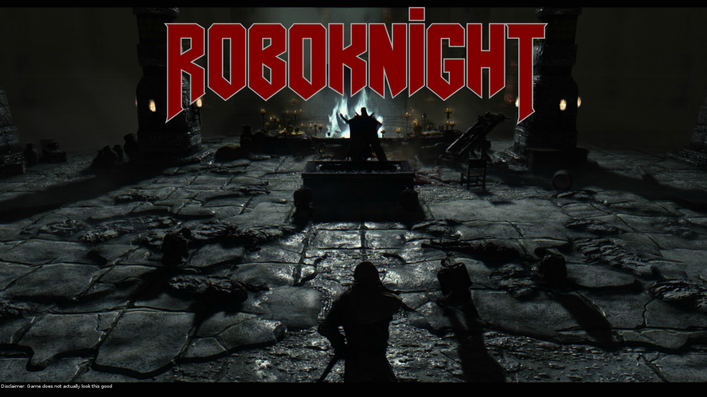

**The action-packed dungeon crawler!**

The official handbook to the *hit* *classic* from *Kim-Jong FunTM*

***Backstory***

The year is 20XX. It is the height of Interdimensional Hyper-Neptunion War III. The whole universe has become a battlefield, and every second billions of lives are lost. But nobody cares about that. Just giving context.

Our story follows the Terrain-Acclimated Battlebot Mk IV, serial code ICS4U1, or I.C. for short (nobody calls him that except for the narrator). He was on transport to the Ultrobelisk HQ for final training before being sent into battle, but his transport vessel became caught in a mysterious gravity well, originating from a nearby unmarked planet. Of course, the vessel took a rather hard landing onto the surface of the planet.

I.C. was wearing his robo-seatbelt, so he survived. The other passengers were not so lucky. Because I.C. is a brainless robot, he sits there for a few centuries, twiddling his robotic thumbs. He eventually gets a little bit bored. With nothing else to do, he exits the vessel and explores landscape outside. After coming across many adventures that are probably more interesting than this game, I.C. stumbles upon a mysterious trap door.

The Battlebot deems it an unnecessary risk to descend into the trap door, but he falls in anyway after tripping on a rock. Yeah. “Terrain-Acclimated.”

After his visual sensors adjusted to the darkness of the cavern in which he sat, he realized he was in some kind of dungeon. He hears a noise coming from the other room. Energy readings are going off the charts in every direction. With nothing but his trusty laser to defend himself, I.C. must brave through this endless\* maze of rooms against the horrors that lurk within. He is last of his kind. He has no other options. He is the protagonist of this video game.

*He* *is* ***Roboknight***.

\*The maze is not actually endless.

***Enemies***

In the ruins of the Temple of \*mumble\*, you will find many evil creatures who see you as nothing but a threat. They will do whatever it takes to destroy you. Here are a few of the monsters that you may encounter on your journey.

|  |  |
| --- | --- |
| **Nanocloud**  ***F:\Sync\School\Gr 11\ICS4U1 - Computer Science\A6_ISU\images\nanocloud.png***This amorphous entity is the embodiment of pure evil. He will slowly move towards you and deal you damage upon contact. | **Turret**  F:\Sync\School\Gr 11\ICS4U1 - Computer Science\A6_ISU\images\turret.pngYou will find many automatons such as these on your adventure. They stand in place and fire projectiles at you. |
| **Weeping Turret**  F:\Sync\School\Gr 11\ICS4U1 - Computer Science\A6_ISU\images\weepingturret.pngVery similar to the Turret, because whoever ~~programmed~~ built this doesn’t have much creativity. This one will only shoot once it’s close enough. It can walk, so watch out! | **Sandman**  F:\Sync\School\Gr 11\ICS4U1 - Computer Science\A6_ISU\images\sandman.pngMade of some kind of red, evil sand, this monster is hard to kill. He moves fast, and he can come back if you don’t shoot his remains quickly enough. |

***Items***

While exploring the maze, you will find many items to make you stronger along the way. Here are some of them:

|  |  |
| --- | --- |
| Aluminum Armour  F:\Sync\School\Gr 11\ICS4U1 - Computer Science\A6_ISU\images\aluminum.pngMakes you move faster! | Li-Ion Battery  F:\Sync\School\Gr 11\ICS4U1 - Computer Science\A6_ISU\images\battery.pngGives you more health! |
| Focus Lens  F:\Sync\School\Gr 11\ICS4U1 - Computer Science\A6_ISU\images\lens.pngYou deal more damage! | Overclocked  F:\Sync\School\Gr 11\ICS4U1 - Computer Science\A6_ISU\images\overclocked.pngYou shoot faster! |

***Shop***

You can exchange items you find for Gold from the Inventory, on the Pause Menu. If you get enough Gold, you can buy new items from the Shop, also on the Pause Menu. Be careful! Once you get an item, you can only sell it for half of its buying value.

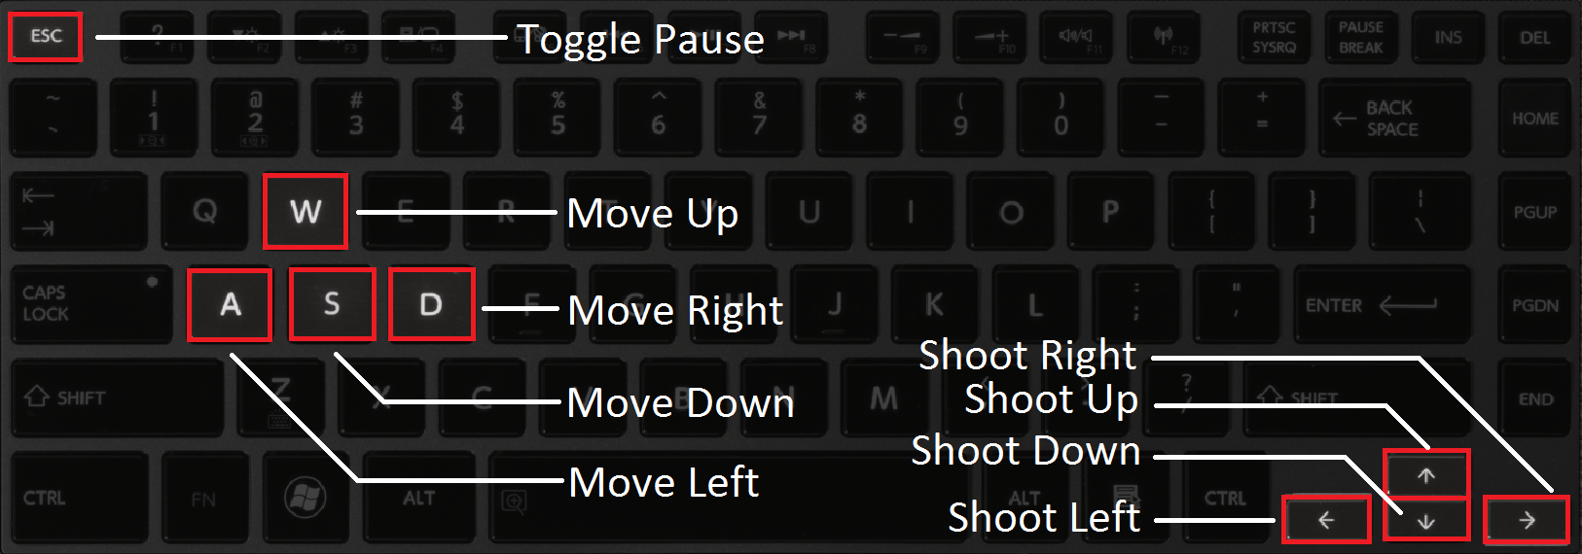

**Keyboard Controls**